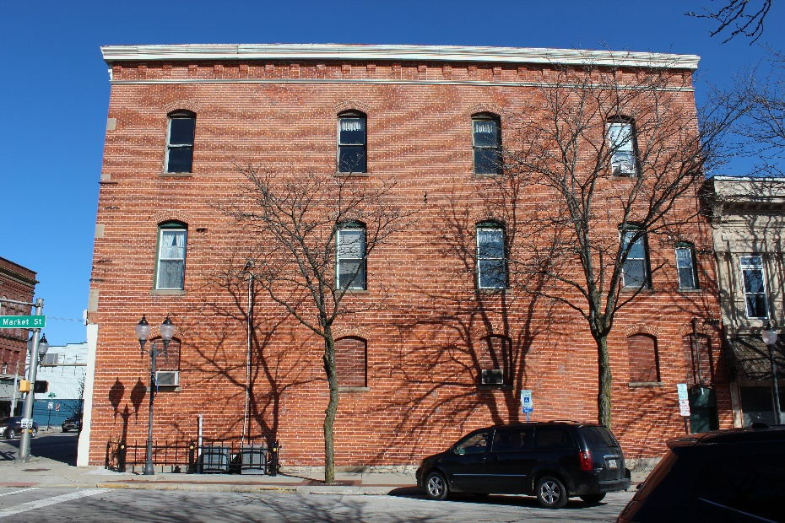
Location:
101 North Main Street
Bluffton, IN

THEME: The goal of this program is to construct a mural within downtown Bluffton that will reflect historical highlights from the City of Bluffton and Wells County. This mural will be constructed in conjunction with a mural being created as part of the Northeast Indiana Make It Your Own Mural Festival.

The Mural Project proposals could reflect the following:
-Historical highlights within the City of Bluffton and Wells County
-Interactive, inviting the viewer to take photos and selfies with the artwork
-A must stop photo destination in downtown Bluffton, IN

LOCATION: This mural will be on the exterior wall of 101 N Main Street, Bluffton, IN. Please see the attached building template and images. The wall is approximately 3000 square feet. The mural can cover the entire brick surface.

INSTALLATION: Our program requires the use of [paint brand if a required brand is used]. We require the artist to coat the finished mural with a UV resistant clear gloss. The budget for artist supplies is listed in the budget (below). Bluffton NOW! will order the supplies; artist is required to stay within the amount budgeted for supplies. Any supplies not used remain the property of the Bluffton NOW!. If scaffolding or rented equipment are required for the project, these costs must also be budgeted within the allotted supply budget.

Artist Stipend: $ 3,000 - $ 8,000
Separate budget available for supplies

PAYMENT
Upon signing the mural contract and waivers, the artist will receive 25% of the artist stipend. Upon completion of the mural and a final review by Bluffton NOW!, the artist will receive the remaining 75% of the artist stipend. Travel, lodging and food will not be paid for by the Program. However, we can help you find inexpensive lodging.

ELIGIBILITY: This is a national call. Artist must be 18 or older. Selected artist will sign an indemnification agreement, a hold harmless waiver, with Program. Selected artist will sign a mural contract with the Program. Selected artist will sign a photo release waiver. Selected artist may be asked to provide proof of insurance.

TIMELINE: Mural specific timeline: AUGUST 2020-SEPTEMBER 30, 2020.
DEADLINE for ENTRY is midnight on Wednesday, August 12, 2020.
NOTIFICATION of ACCEPTANCE: Thursday, August 20, 2020.
All artists will be contacted regarding the status of their application. Upon notification of acceptance, the artist has one week to schedule installation start and finish dates for the mural. Installation timeline can be scheduled: Monday, August 31, 2020.
The artist is required to complete the mural within their scheduled timeline.

SELECTION PROCESS: The jury is made up of 10 members of the Wells County Mural Committee. All applicants will receive notification of selection by Friday, August 21, 2020. Please, do not contact the committee regarding the status of your application.

APPLICATION CHECK-LIST:
MAIL ALL OF THE FOLLOWING in ONE EMAIL to blufftonnow@gmail.com by 11:59pm on Wednesday, August 12, 2020.
Please submit following information for request for qualifications
1) 2 jpeg images of artist's previous work (include description: medium & size)
2) Artist's resume with contact information
3) Availability to install between September 7 – September 30.

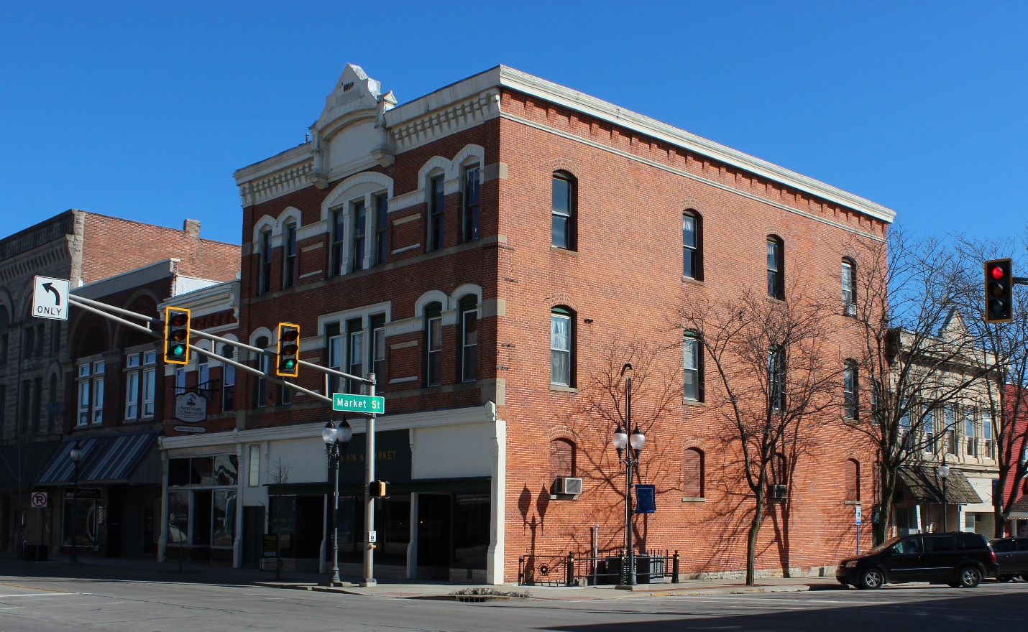

TEMPLATE
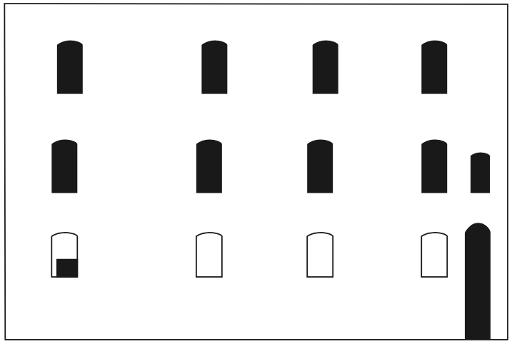
Top

